
FAKULTI SAINS KOMPUTER DAN MATEMATIK
ASAS KEJURUTERAAN PERISIAN (CSF3143)
LECTURER:
PROF. MADYA DR. SHARIFAH MASHITA BINTI SYED MOHAMAD

STUDENT’S NAME:
MUHAMMAD RIZKI BIN JALIUS (S88895)
IMAN THAQIF BIN MOHD KOMARUL ARIPIN (S88847)

TITLE:
CatCare IoT Feeding Machine on Campus

TABLE OF CONTENTS

1. PROJECT BACKGROUND

1.1 Problem Statement and Justification

Problem Statement
Over the past few years, there has been an increasing number of stray cats in the Universiti Malaysia Terengganu (UMT) campus setting. As of now, feeding is done manually by kind-hearted students/staff/volunteers. This causes many issues:

- Inconsistent and Unsupervised Feeding: The feeding is inconsistent based on the availability of volunteers. During semester breaks, public holidays, or busy exam times, there is often an unstable food and water supply for the cats.

- Food Spoilage and Environmental Hygiene Problems: Food can be left out in bowls or on raw surfaces around campus corridors and cafeterias due to manual feeding. The leftover food can attract pests such as ants and rodents. The food will also spoil quickly in the open air and cause hygiene issues for the campus facilities staff.

- Lack of Resource Tracking and Wastage: Volunteers cannot tell if a feeding station is full/empty in real time, leading to feeding stations being overfilled in some places and completely ignored in others.

- Manual Monitoring: Volunteers and management must manually monitor the containers and water tanks at multiple locations on campus to check their levels. This can be very time-consuming and inefficient.

Justification
An automated centralised and intelligent IoT feeding system can be developed to overcome these issues. The CatCare IoT Feeding Machine has been developed to overcome these issues and improve animal welfare on campuses:

- Automation & Timely Feeding: Enables an automated feeding system allowing regular feeding of the cats.

- Smart IoT Monitoring: Sensors allow real-time monitoring of food and water levels within the storage containers. You will be alerted if refilling is needed.

- Improved Campus Hygiene: The food can be dispensed in a controlled manner reducing any spillages making feeding stations clean and hygienic as per UMT standards.

- Efficient Resource Management: No food waste and reduces manual work. Provides useful information for campus volunteers. All information is provided on one website.

1.2 Proposed System Overview
CatCare IoT Feeding Machine in Campus is a software and hardware system designed to automatically feed, monitor and manage stray cats on the UMT campus. This system connects microcontrollers (IoT Hardware) with a web-portal.
Core Architecture and Functionality
The system operates through three primary layers:
- IoT Hardware Layer (Smart Dispenser Unit):

- Motorised Dispenser: This triggers a servo motor to dispense a measured amount of dry cat food.
- Sensors Integration: These include ultrasonic/weight sensors to determine how much space is left in the food container and water level sensors.
- Microcontroller Unit: This device connects to the campus Wi-Fi and sends live data from the sensors to the server. It will also receive commands to dispense.
- Web Management Platform Layer (Software System):

- Dashboard and Live Feed: Shows live data of food levels, water levels and machine statuses within feeding stations on campus.
- Scheduling Management: Enables authorised users/admins to create, edit and/or remove feeding slots and portion sizes.
- Alert & Notification: Triggers alerts on the admin page to inform users that an issue has occurred (e.g., Food Level <15%) so they can refill it.
- Manual Feeding: Enables volunteers to manually trigger a feeding via the web interface.

- User Roles & Access Control:

- Campus Admin/Maintenance Team: Configures the system, keeps track of all machine health. Manages user accounts.
- Student volunteers/Animal Care Club: Can view dispenser levels, feed schedules, manually feed, and receive alerts for maintenance.
Software Development Process
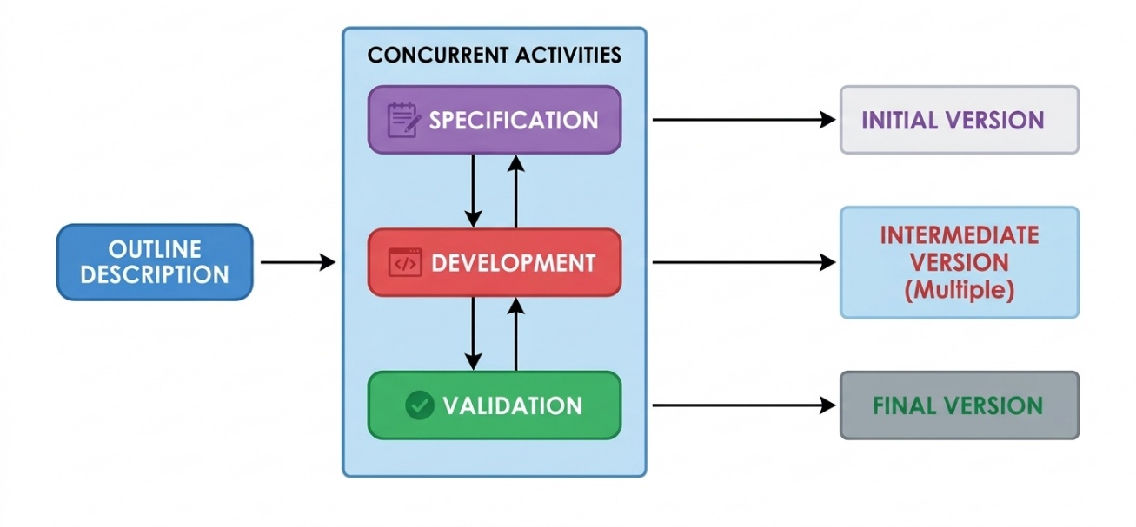
To develop the CatCare IoT Feeding Machine on campus, our team adopted the Incremental Development Model. We selected this process model because it allows us to build and deliver the system in a series of core versions, progressively integrating the IoT hardware components and the web management platform.
The phases involved in the execution of our project are organized as follows:

- Outline Description: The initial conceptualization of the project, the gathering of requirements from actual stakeholders (student volunteers, Animal Care Club members, and campus maintenance staff) within the Universiti Malaysia Terengganu (UMT) campus, and the creation of the GitHub collaboration repository.

- Concurrent Activities (Specification, Development, & Validation): The iterative workflow that runs throughout project cycles, covering system analysis, module coding, and rigorous testing of both software logic and hardware sensor responses.

- Initial Version: Building the foundational layer, centered on the core IoT hardware configuration (ESP32/ESP8266 microcontrollers linked to ultrasonic food/water level sensors and servo motors) connected to a relational MySQL database to manage live data feeds.

- Intermediate Versions: Creating the Web Management Platform layer, adding user authentication with role-based access control (Campus Admin versus Student Volunteers), responsive live dashboards, and manual controls for triggering feeding.

- Final Version: Finishing the advanced system features, such as the automated feeding schedule management module, low-level warning notifications, and full system integration prepared for final deployment and presentation.
1.3 Project Planning (Roles, GitHub & Timeline)
Team Roles and Responsibilities:
The project team consists of 2 members. Each has their own individual module. This has been designed to ensure that the hardware and software components work together well.

- Member 1: Project Leader & IoT Hardware / Backend Architecture Leader

- Responsible for overseeing the whole project, managing communications between the microcontroller and the cloud (ESP32/ESP8266). Integrates sensor data from hardware components (Ultrasonic food/water level sensors) and has created relational database structures (MySQL) along with APIs to send live data.

- Member 2: UI/UX, Schedule Management & Notification Module Leader

- Responsibilities: Manage user authentication and role-based access (Campus Admin and Volunteers). Design responsive dashboards. Develop automated feeding schedules, portion settings and low-level warnings.

Team Biographies


Member 1: Iman Thaqif Bin Mohd Komarul Aripin

- Matric Number: S88847

- Role: Project Leader & IoT Hardware / Backend Architecture Leader

- Biography: Iman Thaqif is a Computer Science student from Universiti Malaysia Terengganu (UMT) specializing in Cloud Computing Security. He has a strong technical background in back-end development, relational databases and integrating systems. He is in charge of the strategic implementation of the project. His main responsibility is to create a stable connection between the IoT devices providing the data and the cloud database.

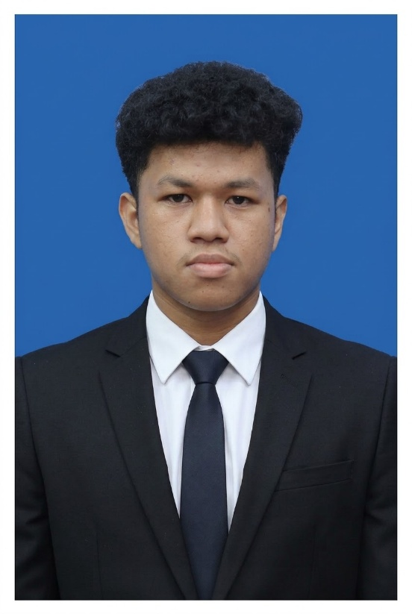

Member 2: Muhamad Rizki Bin Jalius

- Matric Number: S88895

- Role: UI/UX, Schedule Management & Notification Module Leader

- Biography: Muhammad Rizki is a Computer Science student at Universiti Malaysia Terengganu (UMT). He focuses on developing user-focused software applications. His expertise in modern frontend frameworks, user interface prototyping, and structuring business logic makes him the lead developer on the web management system. This ensures that the dashboard is user-friendly, allowing students who volunteer to easily manage their feeding schedule with automatically generated notifications.

GitHub Repository & Activity Details
To ensure transparent project monitoring and version control, the project team actively utilizes GitHub as the central collaboration repository throughout the semester:
- Repository Name: CatCare-IoT-Feeding-Machine-in-Campus-Group-8
- Repository URL: https://github.com/ImanS88847/CatCare-IoT-Feeding-Machine-in-Campus-Group-8
- Collaborators & Access: Both team members and the course lecturer have been granted collaborator access to monitor development milestones in real time.
- Activity & Audit Trail: All project artifacts—including meeting minutes, stakeholder requirement gathering evidence, issue tracking, and incremental source code commits—are regularly updated within the repository to reflect consistent individual and group contributions.

Timeline
Activity | Date
Group Project (GP) formation, project title & GitHub repository submission | 22 October 2026
Milestone 1: Requirements and Use Case Modeling | 15 November 2026
Milestone 2: System Design | 19 November 2026
Submission of Final Report | 24 December 2026
Presentation | 3-7 January 2027

2.SYSTEM REQUIREMENT

  - Stakeholder identification & Requirement Gathering

To ensure the conceptual design of CatCare IoT Feeding Machine on Campus effectively resolves stray cat feeding and sanitation challenges within Universiti Malaysia Terengganu (UMT), requirements were gathered from primary campus stakeholders.

Identified Stakeholder

1. Campus Administration/Maintenance Team (UMT):
Responsible for system configuration, overall machine health monitoring, user account management, and maintaining campus facility hygiene standards.

2. Student Volunteers/Animal Care Club:
Operational users in charge of monitoring dispenser levels, configuring feeding time, starting manual feeding, and refilling alerts.

Requirement Gathering

1. Semi-Structured Interviewing:
Conducted with student volunteers and campus facility representatives to highlight challenges associated with manual feeding, food wastage, and monitoring.

2. Audit and Documentation Trail:
All interview notes, requirements checklist, and virtual meetings held through Google Meet have been documented in the GitHub repository maintained by the team (CatCare-IoT-Feeding-Machine-in-Campus-Group-8) under the evidence and meeting minutes folders.

3. Field Study of Campus:
Identification of locations on campus where stray cats gather in higher numbers (cafeteria areas and hostel corridors of UMT). Determine optimal conceptual station placement and campus Wi-Fi availability.

2.2 Functional Requirements
Functional requirements specify the vital processes and functionalities the CatCare IoT Feeding Machine web management system and the hypothetical IoT-based hardware system must exhibit when taking in inputs, processing them, and producing outputs.
CATEGORY | DESCRIPTION
User Authentication & Role-Based Access Control | The system will allow registered users, which include Campus Administrators and Student Volunteers, to access their accounts through proper logins
User Authentication & Role-Based Access Control | The Role-Based Access Control system will differentiate between the two types of privileges: Administrative Privileges (which deal with configuration of accounts and machine health) and Volunteer Privileges (dealing with scheduling, manual feeding, and monitoring)
User Authentication & Role-Based Access Control | The system shall allow Campus Admins to create, update, or deactivate user accounts
Automated Feeding Schedule Management | Authenticated users will have the ability to create, read, edit, and delete automated feeding times.
Automated Feeding Schedule Management | The system shall allow users to define specific dry cat food portion sizes for each scheduled slot.
Automated Feeding Schedule Management | The system shall transmit scheduled feeding parameters to the ESP32/ESP8266 microcontroller to trigger the servo motor dispenser automatically at the designated times
Manual Remote Dispense Control | The manual control button for feeding should be provided in the system, through which volunteers can immediately feed the animals during off-hours
IoT Sensor Monitoring & Live Dashboard | The system shall receive live ultrasonic/weight sensor readings from the ESP32/ESP8266 microcontroller and display real-time dry food storage levels on the web dashboard
IoT Sensor Monitoring & Live Dashboard | The system shall receive live water level sensor readings and display real-time water container levels on the web dashboard.
IoT Sensor Monitoring & Live Dashboard | The web dashboard shall display the operational connectivity status (Online/Offline) of each campus feeding station
Low-Level Alert & Notification Management | The system shall automatically trigger a visual alert on the admin and volunteer dashboard whenever food or water storage falls below 15% capacity to prompt timely refilling
Low-Level Alert & Notification Management | The system shall store all sensor logs, feeding execution records, and alert histories inside the relational database (MySQL).

2.3 Non-Functional Requirements

CATEGORY | DESCRIPTION
Performance  (Product Requirement) | The web portal shall reflect updated sensor data (food and water levels) transmitted from the ESP32/ESP8266 microcontroller within 3 seconds.
Usability  (Product Requirement) | The web dashboard shall feature an intuitive, responsive UI that adapts seamlessly across desktop computers, tablets, and mobile phones for student volunteers.
Security  (Product Requirement) | All user passwords shall be securely hashed prior to storage in the MySQL database, and restricted administrative endpoints shall block unauthorized access.
Dependability  (Product Requirement) | In the event of temporary UMT campus Wi-Fi interruption, the microcontroller design shall retain active feeding schedules in local memory and sync missed logs once reconnected.
Operational Requirement  (Organizational Requirements) | The MySQL relational database schema and backend APIs shall support adding multiple feeding stations across different UMT campus zones without requiring core system redesign.

2.4 Requirements Checking & Validation
To ensure the quality, integrity, and completeness of the gathered system requirements, the team conducted a systematic Requirements Checking review based on core validation criteria outlined in software engineering standards.
- Validity
The system ensures valid functionality by directly supporting the real operational needs of UMT stakeholders, addressing core issues such as manual feeding inconsistencies, hygiene problems, and lack of real-time monitoring.
- Consistency
All system requirements have been checked for consistency in order to avoid any contradictions, which is why all access rights of users (Campus Admin vs. Student Volunteers) and operation process (automated/manual) have been considered during the process.
- Completeness
Requirements fully describe the operational process of CatCare in terms of user authentication, scheduling, remote manual override, real-time data collection from IoT sensors and low-level alerts.
- Realism
System requirements are realistic and feasible using standard IoT microcontrollers (ESP32/ESP8266) and web technology development (MySQL/Web Portal).
- Verifiability
All requirements can be tested and described, non-functional requirements include measurable metrics (e.g., 15% low-level alert threshold.

